# Task 990 Implementation

1. **Code A4953 overcurrent protection reset mechanism in the motor controller code**

This task is to ensure that we code support for the A4953 overcurrent protection reset mechanism. The A4953 is the driver used to control the APC motor. We just control 2 GPIOs (for standby and directional changes), as well as 1 ADC to adjust the current setpoint. 100% duty cycle results in 2 amps but we typically do not need more than a 2-300mA.

Note: The A4953 overcurrent protection behaves in the same manner but the fault is latched and can only be reset by putting the device into standby mode or by cycling the power to VBB.

The A4953 is put into standby by setting both of the the GPIOs to 0.

This task will require that the code detects that overcurrent protection was triggered using the ADC input.  Then the code can reset the A4953.

For robustness, the code can also put the Allegro in standby after any movement is completed to effectively reset the Allegro even when overcurrent's do not occur.

1. **Hardware Schematic**
2. **PMSM FOC Project Software Architecture**

(1) Timing

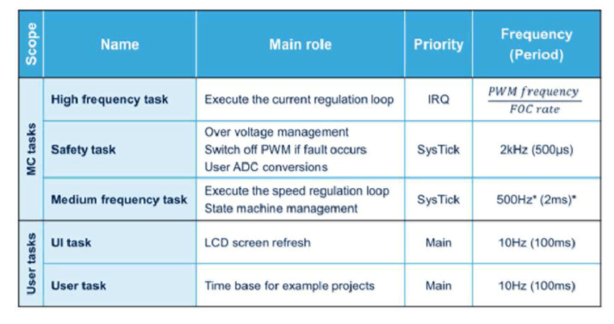

PWM: 24,000 Hz

Current loop (Torque and flux regulators): 24,000 Hz (FOC rate = 1)

Speed loop: 1000 Hz, 1ms

High frequency task: 24000 Hz

Safety task: 2000 Hz

Medium task: 1000Hz

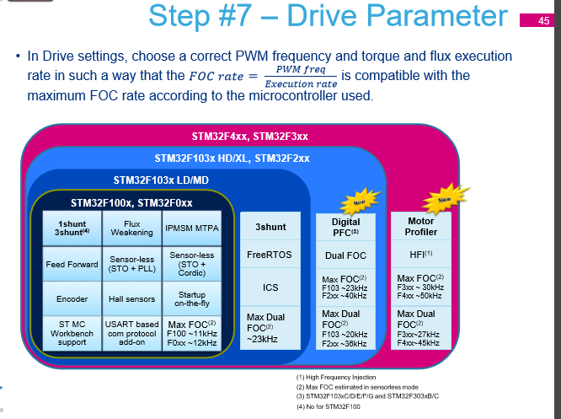

Retrieve from MC Library HandsOn p.45.

(2) ST MC Architecture: Layers

